**2024-2025**

**School Year**

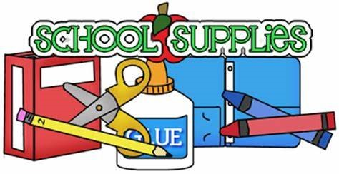

**Kindergarten Supply List**

**Ms. Keys- General Education**

Dear Parents/ Guardians,

Here is a list of supplies that your child will need to begin the year in kindergarten.

**Needed in School**

1-Backpack (large enough to put a folders and workbooks in)

2 boxes – (12 or more) #2 Beginners primary Pencils

2- two-pocket plastic folders

1- primary journal composition notebooks (Mead)

1 six pack- Dry Erase markers (Expo)

2- 16 pack of glue sticks (Elmers)

1- 24 count crayons (Crayola)

1- 8 count washable markers (Crayola)

1- 12 count colored pencils (Crayola)

1- ream of copy paper

2- boxes of 120 count facial tissues

1-roll paper towel

1- large container of Clorox Wipes

1- change of clothes just in case ( pants, shirt, socks, underwear)

1 -set of ear phones

**Keep at Home (to complete homework)**

Pencils

Sharpener

Glue sticks

Crayons

Scissors



Dear Parents & Guardians,

We are looking forward to a great school year! Below you will find a list of supplies that your child will need.

Kindergarten and 1st Grade Supply List:

* 1 box of pencils
* 1 box of crayons
* 1 box of markers
* 1 pack of Expo dry erase markers
* 1 hard pencil case (box)
* 6 Elmers glue sticks
* 2 Elmers Washable Liquid Glue
* 2 pocket folders
* 1 Spiral Notebook (colleged ruled)
* 1 – 2inch binder (hard, with outside clear insert)
* 2 boxes of tissues
* 2 rolls of paper towel
* 1 box quart size Ziploc bags
* 1 box of gallon size Ziploc bag
* 2 large containers of Lysol/Clorox Wipes
* 2 packs of baby wipes
* 1 bottle of Liquid soap
* 1 bottle of hand sanitizer
* 1 set of headphones (with a wire)
* 1 change of clothes just in case (pants, shirt, socks, underwear)

**Please label ALL items with your child’s name**

*Thank you!*

*Mrs. Khan*

**Ms. Branley and Ms. A. Grady**

**First Grade Supply List**

* 1 box of pencils
* 1 box of crayons
* 1 box of markers
* 1 box of colored pencils
* 1 package of Expo dry erase markers
* 4 large glue sticks
* 1 pack of erasers
* 2 marble notebooks
* 4 two pocket folders
* 1 red, 1 yellow, 1 green, 1 blue
* 1 pencil case or pencil box
* 1 container of Clorox wipes
* 2 boxes of tissues
* 1 box of quart size storage bags
* 1 box of gallon size storage bags
* 1 box of JUMBO size storage bags
* 1 pair of headphones
* 1 bottle of hand sanitizer

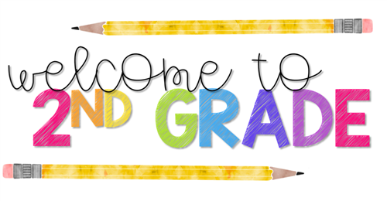

Supplies Needed

* 4 boxes of pencils
* 1 box of crayons
* 1 box of markers
* 1 box of colored pencils
* 1 pair of children’s scissors
* 1 package of Expo dry erase markers
* 10 Elmer’s glue sticks
* 3 composition notebooks
* 5 two pocket folders
* 1 red, 1 yellow, 1 green, 1 blue, 1 of any color or design
* 1 roll of paper towel
* 2 bottles of hand sanitizer
* 1 container of Clorox wipes
* 2 boxes of tissues
* 1 box of gallon size storage bags
* 1 pair of headphones
* Construction Paper
* Ziploc (gallon size bags)
* 1 ream of copy paper
* Please keep extra glue, scissors, crayons, glue sticks and pencils at home as to complete homework

**Please label ALL materials with your child’s FIRST and LAST NAME.**

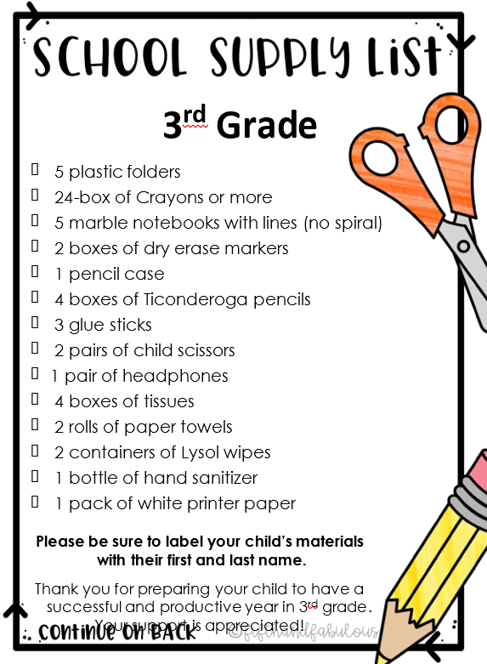



3rd and 4th Grade Supply List

* 3 boxes of pencils
* 1 pencil case (the bigger the better)
* 1 box of crayons
* 1 box of markers
* 1 box of colored pencils
* 1 pair of children's scissors
* 1 package of multi-colored Expo Dry Erase Markers
* 1 package of black Expo Dry Erase Markers
* 10 Elmer’s Glue Sticks
* 6 - ***plastic*** folders (plastic is more durable)

*1 red, *1 yellow, *1 green, *1 blue, *1 green, *1 any design or color

* 6 composition books with lines
* 1 composition book with no lines
* 1 package of ***wide-ruled*** loose leaf
* 1 pack plain white copy/printer paper
* 1 pack of construction paper
* 4 boxes of tissues
* 2 rolls of paper towels
* 2 large containers of Lysol/Clorox wipes
* 1 bottle of Liquid soap
* 1 bottle hand sanitizer
* 1 reusable BPA free water bottle to stay in school
* 1 set of headphones or ear buds

Please label **ALL** materials with your child's **FIRST** and **LAST** name.

Thank you so much for preparing your child to have a successful and productive year in 3rd and 4th grade.  Your support is appreciated!!!

**4th Grade Ms. Barreto- Supply List**

Please be sure to label all items with your child’s name

* **5 Folders** (Please buy plastic folders, they will last longer than paper folders).
* 1 Yellow Folder
* 1 Green Folder
* 1 Red Folder
* 1 Blue Folder
* Student Choice Folder
* 1 Soft pencil case with zipper (Hard Box pencil cases will **not** fit in student desks)
* 6 Marble Notebooks
* 1 Unruled Marble Notebook (NO LINES)
* 3 packs of sharpened pencils
* 12” ruler with both inches and Centimeters
* 1 Pencil sharpener (with lid)
* 24-Box of Crayons (anything bigger will not fit in pencil case)
* 1 scissor
* 2 packs of looseleaf paper
* 6 pack of Glue Sticks (Not liquid glue)
* 1 box of dry erase markers
* 1 box of Sharpie markers
* 1 pack of index cards
* 1 DEAR time chapter book aligned to students DRA level
* 4 boxes of tissues
* 2 boxes of Lysol Disinfecting wipes
* 4 paper towels
* Headphones (labeled)
* 2 packs of construction paper

**Ms. Calvi’s 5th Grade Supply List**

  Please be sure to label all items with your child’s name

* **5 Folders** (Please buy plastic folders, they will last longer than paper folders).
* 1 Yellow Folder
* 1 Green Folder
* 1 Red Folder
* 1 Blue Folder
* Student Choice Folder
* 1 Soft pencil case with zipper (Hard Box pencil cases will **not** fit in student desks)
* 6 Marble Notebooks
* 1 Unruled Marble Notebook (NO LINES)
* 3 packs of sharpened pencils
* 12” ruler with both inches and Centimeters
* 1 Pencil sharpener (with lid)
* 24-Box of Crayons (anything bigger will not fit in pencil case)
* 1 scissor
* 2 packs of looseleaf paper
* 6 pack of Glue Sticks (Not liquid glue)
* 1 box of dry erase markers
* 1 box of Sharpie markers
* 1 pack of index cards
* 1 DEAR time chapter book aligned to students DRA level
* 4 boxes of tissues
* 2 boxes of Lysol Disinfecting wipes
* 4 paper towels
* Headphones (labeled)
* 2 packs of construction paper

**ENL (Title 3)** Ms. Gama, and Mr. Creazzo **SUPPLY LIST**



* 4 packages of multi-colored dry-erase markers /4 *paquetes de marcadores multicolores de borrado en seco*
* 2 boxes of tissues /2 cajas de pañuelos
* 2 rolls of paper towels /*2 rollos de toallas de papel*
* 2 large containers of Lysol wipes /*2 envases grandes de toallitas Lysol*
* Head phones or ear buds /*Auriculares o auriculares*

**Ms. Gama’s Group/ Ms. Gama’s Grupo –**

***Kindergarten****:*

* *1 red plastic folder- 1 folder rojo plastico*

***1st grade:***

* 1 purple plastic folder – *1 folder morado plastico*

**2nd grade:**

* 1 orange plastic folder- *1 folder naranja plastico*

***Para kindergarten, 1st, and 2nd grade:***

* 1- 16 pack of crayons- *1 paquete de 16 crayolas*
* 1- head phones – *audifonos*
* 1- pack of dry-erase expo markers- *paquete de marcadores expo de borrado en seco*
* *1* pack of pencils *– 1 paqueto de lapiz*
* 1 wide ruled composition notebook- *cuaderno de composición con rayas anchas*
* Boxes of tissues, Clorox wipes, paper towels, and hand sanitizer- *Cajas de pañuelos desechables, toallitas Clorox, toallas de papel y desinfectante de manos*

***Please be sure to label all items with your child’s name***

Thank you so much for preparing your child to have a successful and productive year.  Your support is appreciated!!!

***Asegúrese de etiquetar todos los artículos con el nombre de su hijo***  
Muchas gracias por preparar a su hijo para tener un año exitoso y productivo. ¡Se agradece su apoyo!



SUPPLY LIST GRADE 6 Ms. Raczy’s Homeroom

Room 202

Dear Parents,

Below is the following supply list your child is recommended to have for this school year. It is important for students to come to school prepared daily. I look forward to an exciting and successful academic school year! Thank you J

Ms. Raczy

* 5 Folders- HW & Notes , ELA , Math , S.S/Science , Catch-up
* 4 Composition Notebook ELA , Math , S.S/Science, Journal
* One small binder 1 or 2 inches ( Can be the same one from last year)
* 1 homework pad – a notebook is suitable
* 2 Packs of loose leaf- wide ruled
* 2 or more packs of pencils
* 4 or more white board markers
* 1 Individual white board and eraser
* 1 Highlighter
* 1 Pencil Case
* **1 set of headphones for computers and technology *** They will be left in school.**
* 1 pack of markers
* 1 pack of crayons
* 1 pack of colored pencils
* 2 glue sticks
* 1 child safe scissors
* 2 boxes of tissues
* 2 bottles of hand sanitizer
* 2 rolls of paper towels
* Clorox wipes and Lysol

Please label all items. Thank you.

**5th Grade Ms. Calvi- Supply List**

Please be sure to label all items with your child’s name

* **5 Folders** (Please buy plastic folders, they will last longer than paper folders).
* 1 Yellow Folder
* 1 Green Folder
* 1 Red Folder
* 1 Blue Folder
* Student Choice Folder
* 1 Soft pencil case with zipper (Hard Box pencil cases will **not** fit in student desks)
* 6 Marble Notebooks
* 1 Unruled Marble Notebook (NO LINES)
* 5 packs of sharpened pencils
* 12” ruler with both inches and Centimeters
* 1 Pencil sharpener (with lid)
* 24-Box of Crayons (anything bigger will not fit in pencil case)
* 1 scissor
* 2 packs of looseleaf paper
* 6 pack of Glue Sticks (Not liquid glue)
* 1 box of dry erase markers
* 1 box of Sharpie markers
* 1 pack of index cards
* 1 DEAR time chapter book aligned to students DRA level
* 4 boxes of tissues
* 2 boxes of Lysol Disinfecting wipes
* 5 paper towels
* Headphones (labeled)
* 2 packs of construction paper